Solutions for the Module 3 Assignment

1. The dimensions in the problem somewhat difficult because dimensions should be combined in data sources. Item and customer combine parts of both data sources. The calendar dimension is a standard, hierarchical dimension. Email can be parsed to be hierarchical as part of the customer dimension.
- Franchise
  - FranchId: retail database only
  - FranchRegion retail database only
  - FranchPostalCode: retail database only
  - FranchModelType: retail database only
  - For the special events worksheet, selected franchises maintain spreadsheets so the franchise will be derived from the spreadsheet submission.
- Calendar
  - Date columns in the retail database (SalesDate, ServPurchDate, and MmbrDate) and spreadsheet (EventDate); hierarchical (year → month → day)
- Item: combines Merchandise, Service, and Events
  - MerchId (Merchandise table) | ServId (ServiceCategory table)
  - MerchName (Merchandise table) | ServCatName (retail database) | Event Name (spreadsheet)
  - MerchType (Merchandise table) | Event Type Code (spreadsheet)
- Customer: combines members and corporate customers
  - MmbrId (retail database) | Corporate Customer Id (spreadsheet)
  - MmbrName (retail database) | Corporate Customer Name (spreadsheet but must be parsed)
  - Corporate Customer Location (spreadsheet): must be parsed
  - MmbrEmail: retail database; hierarchical (top level domain → second level domain → local part)
  - MmbrZip: retail database only
  - MemTypeId: retail database only

2. The measures come from several tables in the retail database and special events spreadsheet. Measures from related tables are important to associate with the measures from the PurchLine table and Supply Purchases spreadsheet.
- Qty (Contains table); additive measure
- MerchPrice (Merchandise table); non additive measure
- ServCatPrice (ServiceCategory table) | Amount (spreadsheet); non additive

3. The most detailed grain is the combination of individual customer, product or service, franchise, and date. The grain for service purchases and merchandise sales should be computed separately.
- Franchises
  - 350 franchises for merchandise sales
  - 200 franchises for special events
  - Assume that franchises for special events are already included in the franchises with merchandise sales
- Goods for sale
  - Merchandise: 500
  - Service categories: 20
  - Event types: 1
  - Total types of goods/services for sale: 521
- Members and customers
  - Members: 50,000 members in the retail database
  - Corporate customers: 150 customers * 200 franchises (30,000)
  - Total members and customers: 80,000 assuming no overlap
- Fact table size
  - Merchandise purchases: rows in the Contains table (450,000/year)
  - Service purchases: rows in the ServicePurchase table (100,000/year)
  - Special events: worksheet rows (300 events * 200 franchises = 60,000 events per year)
  - Total rows: 610,000 rows per year
- Sparsity estimate:
  - 1 - ( fact table size / product of dimensions )
  - (1 – ( 610,000 / (350*521*365*80,000) ) = 0.999999885
  - The data cube has mostly missing cells with slightly more than 1% of cells with non zero values.

4. The star schema should support the dimensions and measures specified in problems 1 and 2. Franchise was related directly to RevFact instead of customer. All revenue is associated with a franchise. Corporate customers can be associated with multiple franchises so the relationship to RevFact was used. RevFact contains merchandise sales, service purchases, and event occurrences. An alternative design is to split into multiple fact tables. The data warehouse design will be more complex with a constellation schema. The ItemType column in the Item table supports differentiation between merchandise, service, and event revenue so the design with one fact table is preferred.

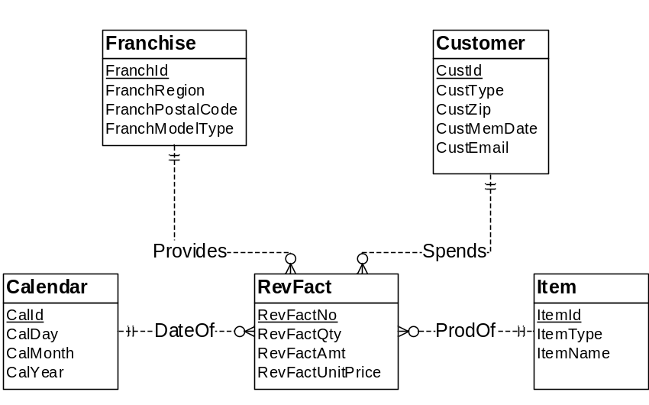
Figure 1: ERD for Fitness Retail Data Warehouse

CREATE TABLE Customer (
CustId INT NOT NULL,
CustType VARCHAR2(10) NOT NULL,
CustZip INT NOT NULL,
CustEmail VARCHAR2(50),
CustMemDate DATE,
CONSTRAINT CustomerPK PRIMARY KEY(CustId) );

-- Could also add other location columns such as city and state

CREATE TABLE Franchise (
FrachId INT NOT NULL,
FranchRegion VARCHAR2(20) NOT NULL,
FranchPostalCode VARCHAR2(10) NOT NULL,
FranchModelType VARCHAR2(10) NOT NULL,
CONSTRAINT FranchisePK PRIMARY KEY(FranchId) );

CREATE TABLE Item (
ItemId INT NOT NULL,
ItemType VARCHAR2(6) NOT NULL,
ItemName VARCHAR2(50) NOT NULL,
CONSTRAINT ItemPK PRIMARY KEY(ItemId) );

CREATE TABLE Calendar (
CalId INT NOT NULL,
CalDay INT NOT NULL,
CalMonth INT NOT NULL,
CalYear INT NOT NULL,
CONSTRAINT CalendarPK PRIMARY KEY(CalId) );

CREATE TABLE RevFact (
RevFactNo INT NOT NULL,
FranchId INT NOT NULL,
ItemId INT NOT NULL,
CustId INT NOT NULL,
CalId INT NOT NULL,
RevFactQty INT NOT NULL,
RevFactAmt DECIMAL(10,2) NOT NULL,
RevFactUnitPrice DECIMAL(10,2) NOT NULL,
CONSTRAINT RevFactPK PRIMARY KEY(RevFactNo) ),
CONSTRAINT RevFactUnique UNIQUE(ItemId, CustId, CalId) );

5. Here are summarizability problems.
- Incomplete dimension-fact relationship for franchise: The spreadsheet lacks franchise information so additional data collection is required. This data collection should not be difficult as each franchise using a spreadsheet can provide these details.
- The ERD and spreadsheet indicate that member type is incomplete for members. Some members do not have member types (guests and corporate event customers). This problem can be resolved by default values for guests and corporate customers.
- Incomplete rollup for location dimension elements because zip codes in member table do not have city and state. More data collection will be necessary to resolve this incompleteness.
- The membership date applies only to members, not corporate customers and guests. There is no resolution for this incompleteness.
- No fact-dimension incompleteness for items: events, services, and merchandise have been combined into items so that each revenue fact is associated with an item.

6. The data warehouse tables have been derived from the sample date in the source tables and spreadsheet. The delivery date for the supply purchases uses the default value of the purchase date since the values are missing the source data. New primary key values have been generated for data from the spreadsheet data source.

Calendar
CalId | CalDay | CalMonth | CalYear
1111 | 10 | 2 | 2013
1112 | 11 | 2 | 2013
1113 | 12 | 2 | 2013
1114 | 13 | 2 | 2013
1115 | 14 | 2 | 2013
1116 | 15 | 2 | 2013
1117 | 16 | 2 | 2013
1118 | 17 | 2 | 2013
1119 | 18 | 2 | 2013
1120 | 19 | 2 | 2013
1121 | 20 | 2 | 2013
1122 | 21 | 2 | 2013

Item
ItemId | ItemName | ItemType
1111 | Wilson balls | MRCH
1112 | Wilson racket | MRCH
1113 | Adidas shoes | MRCH
1114 | Racket stringing | MRCH
1115 | Ball machine | PASS
1116 | Private lesson | PASS
1117 | Adult class | PASS
1118 | Child class | PASS
1119 | Adult social | EVNT
1120 | Pioneer social | EVNT
1121 | Team practice | EVNT
1122 | Platinum membership | MMBR
1123 | Gold membership | MMBR
1124 | Value membership | MMBR

- Item identifiers were added for events.
- Item identifiers were changed to integers.

Franchise
FranchId | FranchRegion | FranchPostalCode | FranchModelType
1111 | Northwest | 98011 | Full
1112 | Mountain | 80111 | Medium
1113 | Central | 45236 | Limited

- Franchise identifiers were changed to integers.

Customer
CustId | CustName | CustZip | CustType | CustMemDate | CustEmail
1111 | Joe | 80111 | M1 | 1-Feb-2009 | joe@serv1.com
2222 | Mary | 80113 | M2 | 1-Jan-2010 | mary@serv2.com
3333 | Sue | 80114 | M3 | 3-Mar-2011 | sue@serv3.com
4444 | George | 80112 | M4 |  | george@serv4.com
5555 | Frist Data | 80111 | M5
6666 | DU Tennis | 80117 | M5
7777 | Creek | 80111 | M5

- New customer types were created for non members (M4) and corporate customers (M5)
- Zip codes were added for corporate customers. New data collection is necessary.
- Customer identifiers were added for corporate customers.
- CustMemDate is null (inapplicable) for corporate customers and guests.
- Email addresses were not collected for corporate customers but it may be possible to collect values if desired.

RevFact
RevFactNo | CustId | CalId | ItemId | FranchId | RevFactQty | RevFactAmt | RevFactUnitPrice
1 | 1111 | 1111 | 1111 | 1111 | 2 | $30 | $15
2 | 1111 | 1111 | 1112 | 1111 | 1 | $200 | $200
3 | 2222 | 1113 | 1114 | 1112 | 1 | $40 | $40
4 | 3333 | 1113 | 1113 | 1113 | 1 | $100 | $100
5 | 4444 | 1114 | 1114 | 1113 | 1 | $40 | $40
6 | 1111 | 1114 | 1114 | 1111 | 1 | $15 | $15
7 | 2222 | 1115 | 1116 | 1112 | 1 | $75 | $75
8 | 4444 | 1116 | 1117 | 1113 | 1 | $150 | $150
9 | 5555 | 1114 | 1119 | 1111 | 1 | $1,000 | $1,000
10 | 6666 | 1115 | 1120 | 1111 | 1 | $500 | $500
11 | 7777 | 1122 | 1121 | 1112 | 1 | $200 | $200
12 | 8888 | 1111 | 1122 | 1112 | 1 | $1,000 | $1,000
13 | 9999 | 1116 | 1123 | 1113 | 1 | $800 | $800
14 | 9998 | 1122 | 1124 | 1113 | 1 | $300 | $300

- The RevFact table uses data from the Sale, Contains, and ServPurchase tables as well as the event spreadsheet.

